AI for earth Mid term report "Rehabilitation-and-Protection-of-Coastal-Areas"

**Table of Contents**

**Chapter Index:**

**Chapter 1: Introduction**

1.1 Introduction

1.2 Motivation

1.3 Problem Definition

1.4 Existing Systems and its comparison table

1.5 Lacuna of the existing systems

1.6 Relevance of the Project

1.7 Methodology employed for development (Waterfall, Iterative etc)

**Chapter 2: Literature Survey** (with citation of references)

2.1 Literature survey ( Newspaper Articles , Interaction with domain experts (if any) book articles, etc)

2.2 Research Papers Referred ( Mentioned in IEEE format )

     a. Abstract of the research paper ( in your own word)

     b. Inference drawn

**Chapter 3: Requirement Gathering**

3.1 Definition of requirement gathering

3.2Functional Requirements

3.3 Non-Functional Requirements

3.4.Constraints

3.5.Various Hardware,  Software , Technology and tools available

3.6 Selection of the Hardware,  Software , Technology and tools (Justification for the selection)

**Chapter** 4**: Proposed Design**

4.1 Block diagram of the system --along with its explanation

4.2 Modular design of the system --along with its explanation

4.3 Detailed Design (DFD - level 0,1,2, State Transition Diagram, ER Diagram, Use case diagram etc...) ---with its explanation

4.4 Project Scheduling & Tracking using Time line / Gantt Chart ----with its explanation

**Chapter 5: Implementation Details**

5.1. Algorithms and flowcharts for the  respective modules developed

5.2. Comparative Analysis with the existing algorithms

**Chapter 6: Testing**

6.1 . Definition of testing

6.2. Types of tests

6.3. Type of Testing considered with justification

6.4 Various test case scenarios considered

6.5. Inference drawn from the test

**Chapter 7: Result Analysis**

7.1. Module(s) under consideration

7.2. Parameters considered

7.3.  Screenshots of User Interface (UI) for the respective module ---with its explanation

7.4.  Evaluation of the developed system

7.5. Reports generated / Tables obtained

**Chapter 8:  Conclusion**

8.1 Limitations

8.2 Conclusion

8.3 Future Scope

**9. References**

9.1.Newspaper articles referred

           9.2. Research Papers Referred (IEEE format)

**List of Figures:**

|  |  |
| --- | --- |
| **Figure Name** | **Page No.** |
| Fig 4.1: System Block Diagram | 14 |
| Fig 4.2: Block Diagram | 15 |
| Fig 4.3: Modular Design of the system | 16 |
| Fig 4.4: DFD level 0 | 17 |
| Fig 4.5:DFD level 1 | 18 |
| Fig 4.6:DFD Level 2 | 19 |
| Fig 4.7:ER Diagram | 20 |
| Fig 4.8:Sequence diagram | 21 |
| Fig 4.9: Gantt Chart | 22 |
| Fig 5.1:Flowchart | 24 |
| Fig 5.2: HSV Representation of Color | 25 |
| Fig 5.3:HSV Distribution and Histogram | 26 |
| Fig 5.4: Isolating Red Hues | 26 |
| Fig 6.1:Test Case 1 for before | 28 |
| Fig 6.2:Test Case 1 for after | 29 |
| Fig 6.3:Test Case 1 for change | 29 |
| Fig 7.1 | 31 |
| Fig 7.2 | 31 |
| Fig 7.3 | 32 |
| Fig 7.4 | 32 |
| Fig 7.5 | 33 |
| Fig 7.6 | 33 |

**List of Tables:**

|  |  |
| --- | --- |
| Table Name | Page No. |
| Table 7.1:Report generated | 34 |

**Chapter 1: Introduction**

**1.1 Introduction**

Mangrove area is an important coastal ecosystem in the tropical and subtropical coastal  regions. It is amongst the most ecologically, environmentally and biologically diverse ecosystem in the world. Managing of mangrove is challenging and complex balancing between ecosystem protections and enabling human to enjoy and use these natural resources. Knowledge to obtain information on ecosystem including mangrove community is important.

Benefits of Mangroves:

Like coral reefs, mangrove forests are extremely productive ecosystems that provide numerous good and services both to the marine environment and people.

The goods and services include:

**● Fisheries:** Mangrove forests are home to a large variety of fish, crab, shrimp, and mollusk species. These fisheries form an essential source of food for thousands of coastal communities around the world. The forests also serve as nurseries for many fish species, including coral reef fish. A study on the Mesoamerican reef, for example, showed that there are as many as 25 times more fish of some species on reefs close to mangrove areas than in areas where mangroves have been cut down. This makes mangrove forests vitally important to coral reef and commercial fisheries as well.

**● Coastal protection:** The dense root systems of mangrove forests trap sediments flowing down rivers and off the land. This helps stabilize the coastline and prevents erosion from waves and storms. In areas where mangroves have been cleared, coastal damage from hurricanes and typhoons is much more severe. By filtering out sediments, the forests also protect coral reefs and seagrass meadows from being smothered in sediment.

**● Tourism:** Given the diversity of life inhabiting mangrove systems, and their proximity in many cases to other tourist attractions such as coral reefs and sandy beaches, it is perhaps surprising that only a few countries have started to tap into the tourism potential of their mangrove forests.

**1.2 Motivation**

Permanent destruction of forests or water reserves to make the land available for other uses is increasing rapidly form last several years. Consequences are related to increased loss of biodiversity and land encroachment. Change detection for deforestation and water reserves is the problem of detecting the changes in the earth where people are intentionally trying to destroy the forest and water reserves areas. Images collected from Satellite needs real-time change detection of such activities timely, so that, the deforestation and water reserves can be saved before they get destroyed. It can be significantly advantageous if we can detect the changes from the Satellite images but, it is not feasible to track the changes manually in the Satellite images.

**1.3 Problem Definition**

Mangroves play an important role in coastal areas due to their benefits. Their degradation would lead to consequences related to increased emissions of greenhouse gases, pollution of water, and loss of biodiversity. Nowadays, due to the growing degradation of mangroves near coastal areas, there is a need to determine those areas where the mangrove percentage has decreased. For this, there is a need of an automated system which can provide information by processing large number of images timely and yet accurate.

**1.4 Existing system and its comparison table**

There is no existing system.

**1.5 Relevance of Project**

These results would not only benefit our work, but also the work of thousands of other practitioners and researchers,who find it difficult to analyse the changes in the environment.The system will be open-source.We will disseminate our results close to coastal areas in India and across the larger network, which will in turn help to advance land monitoring and biodiversity conservation science across various Indian states  and other places.

**1.6 Methodology employed for development**

● Step 1: Data gathering

The Landsat 8 images have been collected from USGS.

● Step 2: To detect mangrove’s cover of a region from satellite images collected

For identification of mangroves, color image segmentation method is used.It divides a colored image into a set of disjoint regions which are homogeneous with respect to some properties consistent with human visual perception, such as colors or textures.

● Step 3: To detect the change in mangrove cover of a region

In this step, we use Landsat satellite images of an area and by using remote sensing technology and calculate change in mangrove cover.

**Chapter 2: Literature Survey**

**2.1. Articles referred / news  paper referred: -**

**Satellite images show Navy station reclaimed 60% mangroves in Mumbai: NGO[9] (Hindustan Times)**

A city-based non-government organisation (NGO) has alleged that illegal reclamation by the Indian Navy Station (INS) Hamla led to a 60% drop in mangrove cover at an area owned by the latter near Nau Sena Bagh, Marwe, Malad (West). NGO Watchdog Foundation filed complaints with the state mangrove cell and the Mumbai suburban collector. The NGO attached satellite images from 2013 and 2017 that show a significant drop in green cover at the patch.

**Mangrove research and training centre in Dharavi soon[10](DNA)**

A full-fledged mangrove research and training centre will be set up at the Maharashtra Nature Park (MNP) in Dharavi.This centre will house a well laid out interpretation arena that will educate people not only about mangroves but also coastal bio-diversity in an interactive way as well as have a library with books and documents relating to mangroves and other marine subjects.

**2.1. Research Papers: -**

**1. Automatic Extraction Of Mangrove Vegetation from satellite data[1]**

**Abstract:**Mangrove, the intertidal halophytic vegetation, are one of the most significant and diverse ecosystem in the world. They protect the coast from sea erosion and other natural disasters like tsunami and cyclone. In view of their increased destruction and degradation in the current scenario, mapping of this vegetation is at priority. Globally researchers mapped mangrove vegetation using visual interpretation method or digital classification approaches or a combination of both (hybrid) approaches using varied spatial and spectral data sets. In the recent past techniques have been developed to extract these coastal vegetation automatically using varied algorithms. In the current study we tried to delineate mangrove vegetation using LISS III and Landsat 8 data sets for selected locations of Andaman and Nicobar islands. Towards this we made an attempt to use segmentation method, that characterize the mangrove vegetation based on their tone and the texture and the pixel based classification method, where the mangroves are identified based on their pixel values. The results obtained from the both approaches are validated using maps available for the region selected and obtained better accuracy with respect to their delineation. The main focus of this paper is simplicity of the methods and the availability of the data on which these methods are applied as these data (Landsat) are readily available for many regions. Our methods are very flexible and can be applied on any region.

**Inference:**

● In this paper a focus is given  to recognize and extract the mangroves vegetation based on the false color composite of satellite images of LISS- III using color and texture elements and True color composite of Landsat 8 using the pixels values.

●  Mangroves have dark red velvety tone and smooth texture. Various methods to recognize mangroves have been implemented and their time complexity and accuracy are studied.

● The methods implemented in this study using LISS- III data are K-means clustering, Gabor filtering, Otsu’s threshold method and Texture and color segmentation. SVM classification and Color based pixel classification are implemented using the Landsat 8 images.

**2. Building change detection using multi-sensor and multi-view angle imagery[2]**

**Abstract:** A method for detecting buildings from satellite/aerial images is proposed in this paper. The aim is to extract rectilinear buildings by using hypothesis. Hypothesis generation is accomplished by using edge detection and line generation methods. Hypothesis verification is carried out by using information obtained both from the color segmentation of HSV representation of the image. Satellite images is firstly filtered to sharpen the edges. The edges are extracted using Canny edge detection algorithm. These edges are the input for the Hough Transform stage which will produce line segments according to these extracted edges. Then, extracted line segments are used to generate building hypothesis. Verification of these hypotheses makes use of the outputs of the HSV color segmentation. In this study, color segmentation is processed on the HSV representation of the satellite/aerial images which are less sensitive to the illumination. Finally, Buildings are extracted from the urban areas.

**Inference:**

● This method integrates the sensor model parameters into the co-registration process to relate corresponding pixels. From the corresponding pixels, corresponding segments (patches) are generated. Later on, the brightness values of the matching pixels/segments are compared in order to detect changes. Here, a Multivariate Alteration Detection (MAD) transform is used for identifying the changed segments.

● The proposed method provides the opportunity to utilize various images as bitemporal sets for change detection.

**3. Monitoring land use changes associated with urbanization: An object based image analysis approach [4]**

**Abstract:**Land use/land cover (LULC) change occurs due to natural and anthropogenic causes. In developing countries, rapid industrialization and urbanization imposes a major threat to natural environment. Present study was carried out to monitor the LULC changes due to urbanization in a rapidly changing river basin, India. The purpose of choosing the river basin was to analyze past changes and predict possible consequences within a defined natural boundary. Multi-temporal images acquired from Landsat and Indian Remote Sensing (IRS) satellites between 1992-2009 as well as a digital elevation model was used to generate historical and current LULC pattern in the basin. An object based image analysis technique was employed for precise classification of multi-temporal images followed by GIS-based change detection studies. The study reveals that the built up area has increased significantly and added 288 km2 between 1992 - 2009. Increase in built up area is attributed to decrease in wastelands and agricultural land. The expansion of built up area along major transportation networks, specifically after the year 2000 shows the rapid rate of urbanization in the basin.

**Inference:**

● The paper focuses on determining the land use and land cover changes due to urbanisation.

● An object based detection technique is used on Satellite images further GIS based change detection.

**4. Automated Building Extraction from High-Resolution Satellite Imagery in Urban Areas Using Structural, Contextual, and Spectral Information[5]**

**Abstract:**High-resolution satellite imagery provides an important new data source for building extraction. We demonstrate an integrated strategy for identifying buildings in 1-meter resolution satellite imagery of urban areas. Buildings are extracted using structural, contextual, and spectral information. First, a series of geodesic opening and closing operations are used to build a differential morphological profile (DMP) that provides image structural information. Building hypotheses are generated and verified through shape analysis applied to the DMP. Second, shadows are extracted using the DMP to provide reliable contextual information to hypothesize position and size of adjacent buildings. Seed building rectangles are verified and grown on a finely segmented image. Next, bright buildings are extracted using spectral information. The extraction results from the different information sources are combined after independent extraction. Performance evaluation of the building extraction on an urban test site using IKONOS satellite imagery of the City of Columbia, Missouri, is reported. With the combination of structural, contextual, and spectral information, 72.7% of the building areas are extracted with a quality percentage 58.8%.

**Inference:**

● In this paper, IKONOS satellite imagery is used to test our integrated building-extraction strategy.

● In this paper, an automated building-extraction strategy for high-resolution satellite imagery is proposed that utilizes structural, contextual, and spectral information.

**5. Thresholding and Fuzzy Rule-Based Classification Approaches in Handling Mangrove Forest Mixed Pixel Problems Associated with in QuickBird Remote Sensing Image Analysis[6]**

**Abstract:**Mangrove forest is an important coastal ecosystem in the tropical and sub-tropical coastal regions. It is among the most productivity, ecologically, environmentally and biologically diverse ecosystem in the world. With the improvement of remote sensing technology such as remote sensing images, it provides the alternative for better way of mangrove mapping because covered wider area of ground survey. Image classification is the important part of remote sensing, image analysis and pattern recognition. It is defined as the extraction of differentiated classes; land use and land cover categories from raw remote sensing digital satellite data. One pixel in the satellite image possibly covers more than one object on the ground,within -class variability, or other complex surface cover patterns that cannot be properly described by one class. A pixel in remote sensing images might represent a mixture of class covers , within-class variability, or other complex surface cover patterns. However, this pixel cannot be correctly described by one class . These may be caused by ground characteristics of the classes and the image spatial resolution. Therefore , the aim of this research is to obtain the optimal threshold value for each class of landuse/landcover using a combination of thresholding and fuzzy rule-based classification techniques. The proposed techniques consist of three main steps; selecting training site, identifying threshold value and producing classification map. In order to produce the final mangrove classification map, the accuracy assessment is conducted through ground truth data, spectroradiometer and expert judgment. The assessment discovered the relationship between the image and condition on the

ground, and the spectral signature of surface material in identifying the geographical object.

**Inference:**

● This paper focuses on Clustering and Thresholding the image.

● Thresholding is used to separate image into equally exclusive and unique areas.

● The final output would gives us separation of Open Land areas, water areas, mangrove cover.

**6. Very High Resolution Satellite Image Filtering**[7]

**Abstract:**This paper introduces a new non linear filter suitable for artifacts (trees, cars, etc.) removing in Very High Resolution Satellite (VHRS) Images. It is based on the application of three filters of different sizes and shapes that permits each time to remove the artifacts smaller than the filter. These filters are based on the research of noisy pixels surrounded by homogenous area according to the three filters. First, tests have been conducted on Berkeley database images corrupted with different kinds of noise comparing the filter performances to that of anisotropic diffusion and bilateral filters. In a second stage, we applied our filtering technique to HRS images obtaining promising results.

**Inference:**

● The paper presents an approach to filter the images in order to remove any kind of noise from the image.

● It uses three non linear filters viz. anisotropic diffusion, bilateral filter and mean-shifter filter.

● Further it shows the effect of above filtering techniques on colored images and VHR satellite images.

**7. Water Bodies Identification From Multrispectral Images Using Gabor Filter, FCM And Canny Edge Detection Methods**[8]

**Abstract:**Water bodies identification using multispectral images is a very useful application of image processing. This paper proposed a novel method for water bodies identification from multispectral images using Gabor filter, Fuzzy c-means and canny edge detection algorithm. Gabor filter is a combination of lowpass filter and bandpass filter. This two filters extracting the importance features from satellite images. From the extracted features fuzzy c-means algorithm clustered the various land use and land cover classes. Finally water bodies are identified from land use and land cover classes with the use of canny edge detection methods. The proposed approach was experimented with the use of Landsat7, Landsat-8 satellite images. Our experimental results proved that proposed methods provides better result for water identification with high efficiency.

**Inference:**

● This paper focuses on marking the edges of a water body after performing a series of steps.At first the feature extraction on satellite images is performed using gabor filter.

● Next the land cover and land use classification is done using FCM. Lastly water body segmentation is done using canny edge detection and thus a water body is identified.

**Chapter 3: Requirement Gathering**

**3.1 Definition of requirement gathering**

Requirements gathering is the process of generating a list of requirements (functional, system, technical, etc.) from the various stakeholders (customers, users, vendors, IT staff, etc.) that will be used as the basis for the formal [Requirements Definition](http://www.inflectra.com/Ideas/Topic/Requirements-Definition.aspx). The process is not as straightforward as just asking the stakeholders what they want the system to do, as in many cases, they are not aware of all the possibilities that exist, and may be limited by their immersion in the current state. The contents of the statement of requirements should be stable or change relatively slowly. Once you have created your statement of requirements, ensure the customer and all other stakeholders sign-up to it and understand that this, and only this, is being delivered. Finally, ensure you have cross-referenced the requirements in the statement of requirements with those in the project definition report to ensure there is no mismatch.

**3.2 Functional Requirements**

The requirements for the project comprises of :-

1. Gather SAR images with respect to coastal areas with an interval span of 3 years for the same  region for past 3 decades.

2. Gather factors to detect mangroves in a SAR Image.

3. Gather factors to detect the urban development in a SAR Image.

4. Segment the images to clean and extract only areas related to mangroves and urban development around such regions.

5. Map the factors in step 2 with the cleaned images in step 4 to create an outline on the images  with respect to mangroves.

6. Map the factors in step 3 with the cleaned images in step 4 to create an outline on the images  with respect to urban development.

7. Generate difference images between current and historical remote sensed image and color

code the difference images with respect to change in water and land coverage.

8. Provide a report on various changes in the coastal area cover.

9. Analyze the alternate factors that leads to the same issues that would result with unavailability of mangroves like climate change, etc.

**3.3. Non-Functional Requirements**

1. The data stored can be encrypted locally to protect from any local copy or theft of device (laptop/handheld device).
2. Validating the platform independent format before inserting it into the centralized repository (database).
3. Performance
4. Response time
5. Efficiency
6. Effectiveness

**3.4. Constraints**

* For this project we have collected images of coastal areas of Maharashtra which were not available readily.
* High speed of computations is essential to process large amount of data.

**3.5.Various Hardware,  Software , Technology and tools available**

* For the development and experimentation of the project, Python based Computer Vision and Deep Learning libraries will be exploited.
* Libraries such as OpenCV, TensorFlow,Numpy,Matplotlib will be used.
* Training will be conducted on NVIDIA GPUs for training the end-to-end version of DNN based change detection model.
* For deployment Microsoft Azure is used.

**3.6 Selection of the Hardware, Software, Technology and tools**

**Hardware:**

Computer System:

As huge datasets are used in the project the system with high speed is used for the project with the following configuration:

Processor: i7 intel processor(8th generation)

Graphic card: NVIDIA 4GB

RAM: 8 GB and above

HDD: 1TB and more

OS: Windows 10/Linux

**Software**:

1) OpenCv

OpenCV is the most popular and well known Image Processing library which is widely used in Python and also in many different languages. OpenCV (Open Source Computer Vision) is a library of programming capacities which for the most part went for constant PC vision. The library is cross- platform and free for use under the open-source BSD license. OpenCV bolsters the Deep Learning Structures Torch/PyTorch.

* **Matplotlib** is a plotting library for the Python programming language and its numerical mathematics extension **NumPy**.

2) Azure

Microsoft Azure is an ever-expanding set of cloud services to help organisation meet various business challenges. It is the freedom to build, manage and deploy applications on a massive, global network using tools and frameworks of one’s choice.Azure services  uses advance machine learning to accomplish AI image Processing on large scale and for Prediction of Catchment areas. The services we used include Virtual Machines, Storage,Azure SQL Database, App Service, Machine Learning Studio.

3) UI Path

UiPath Studio allows to create two types of standalone automation projects: process or library. Processes can incorporate all types of workflows, sequence, flowchart, state machine and global exception handler, while the latter isn't available for libraries. Moreover, [**libraries**](https://studio.uipath.com/docs/about-libraries) can be added as dependencies to automation processes.UiPath Studio was used for the automation of collecting  the images from USGS Landsat8.

4) USGS Landsat imagery

The long temporal record of data from Landsat satellites has remained remarkably unbroken, proving a unique resource to assist a broad range of specialists in managing the world’s food, water, forests, and other natural resources for a growing world population.  It is a record unmatched in quality, detail, coverage, and value.

5) Google my maps

To let the user select the location dynamically from the map, Here we’ve used Google my maps api. It will allow user to select the location by clicking on the desired area instead of entering all the details such as coordinates, paths manually.

**Chapter** 4**: Proposed Design**

**4.1 Block diagram of the system :**

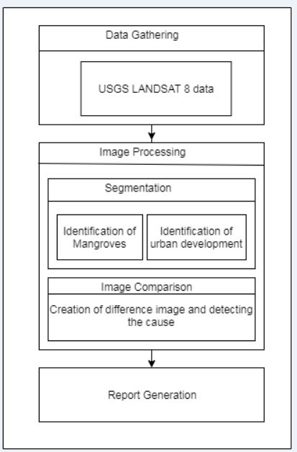

**Fig 4.1: System Block Diagram**

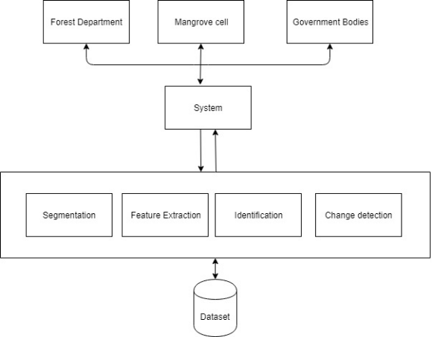

**Fig 4.2: Block Diagram**

The data gathering processing will be done using USGS LANDSAT8 images.The next step involves image processing.It is divided into two modules: Segmentation and image comparison.In case of Segmentation, identification of mangroves and urbanization will take place.After segmentation, the images will be compared and a difference image will be produced. With the help of this,cause will be determined and report will be generated on the same.

**4.2 Modular design of the system --along with its explanation**

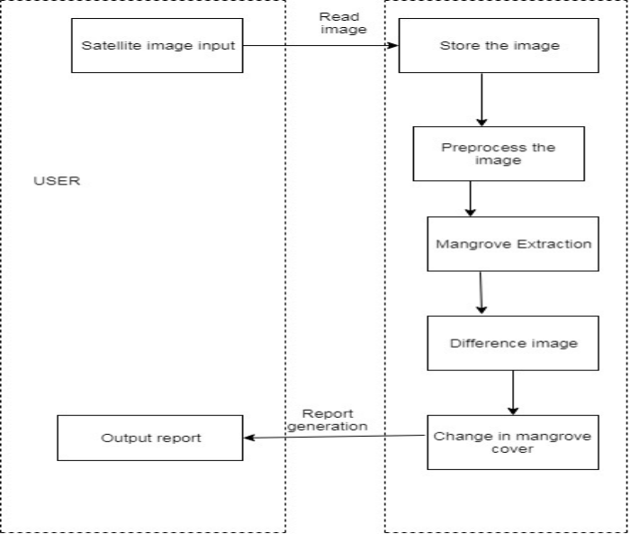

**Fig 4.3: Modular Design of the system**

In the modular diagram above, there are two modules: User and System.

The task of the user is to provide satellite images as input and obtain the output report.

The system has the task of reading image, storing and pre-processing it. Extraction of mangrove is done in the next step and a difference image is produced .This difference image helps in determining the change in mangrove cover.

**4.3 Detailed Design**

a) Data Flow Diagram ( Level 0,1,2)

(A)DFD level 0: -

The DFD Level 0 briefly shows the overall functionality of the system. The user captures the multiple satellite images of the area ,which is the input to the system. The system consisting of many other components along with the Image Processing techniques and the ability of Machine Learning accurately identifies the mangrove cover and calculates the difference in the mangrove cover. It finally generates the report based on the change in the mangrove cover.

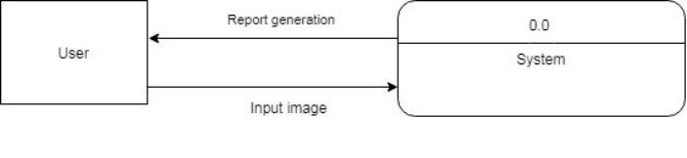

**Fig 4.4: DFD level 0**

B) DFD level 1: -

The user first captures the satellite images of the area , which is input to the system. The next step is Image Pre-Processing. The aim of pre-processing is an improvement of the image data that suppresses unwanted distortions or enhances some image features.The system processing would identify the mangrove cover in given images and calculate the change in the mangrove cover. This change information is basis for the report generation.

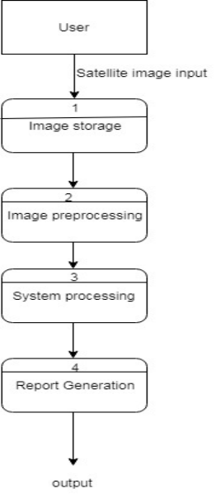

**Fig 4.5:DFD level 1**

(C) DFD level 2: -

1) The system receives image data and first performs image segmentation.

2) It identifies the boundaries of the objects present in the image based on their texture,

Colour, etc.

3) It then performs Feature Extraction to know more about the details of the objects.

4) Finally, the identification of mangrove cover, urbanization is performed.

5) The process gets completed and these areas are identified in the image.

6) The difference image is calculated based on the previous step result.

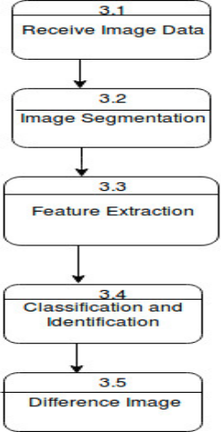

**Fig 4.6: DFD Level 2**

b) ER Diagram

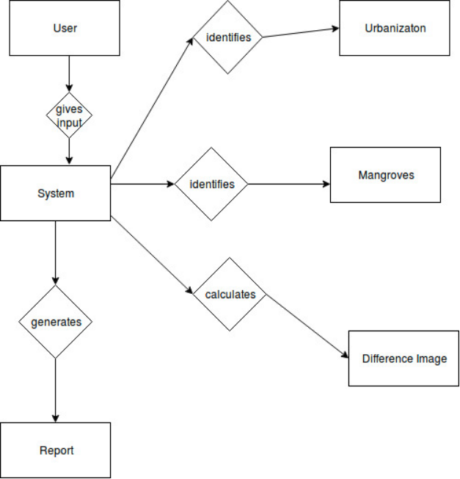

**Fig 4.7: ER Diagram**

c)Sequence Diagram:

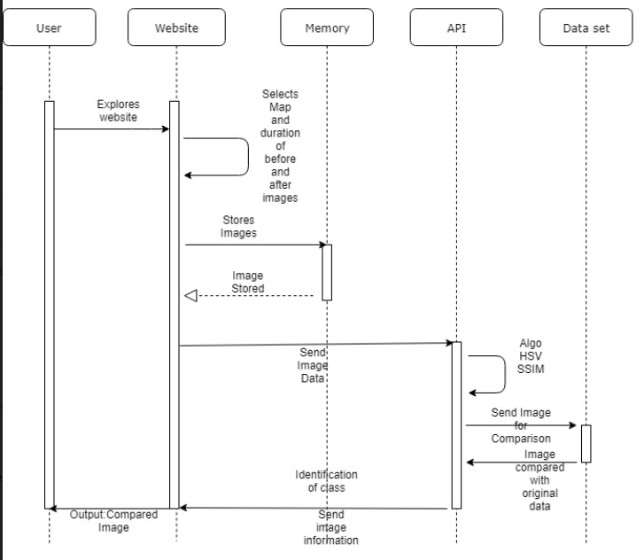

**Fig 4.8: Sequence diagram**

**4.4 Project Scheduling & Tracking using Timeline / Gantt Chart**

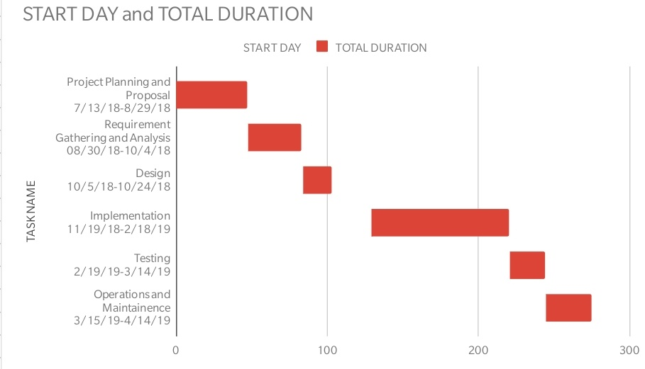

Fig 4.9: Gantt Chart

**Chapter 5: Implementation Details**

**5.1 Algorithms and flowcharts for the respective modules developed**

a)Flowchart for the proposed system

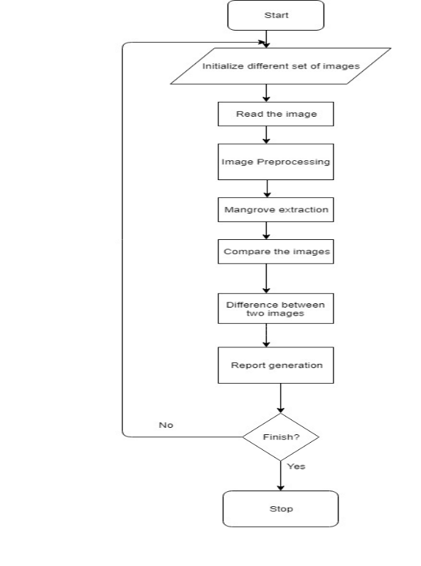

**Fig 5.1:Flowchart**

b)Algorithms Used:

Different algorithms and techniques used to detect the change in mangrove cover are as follow:

1. **SSIM** -

The **structural similarity** (SSIM) index is a perception-based model that considers image degradation as *perceived change in structural information*, while also incorporating important perceptual phenomena, including both luminance masking and contrast masking terms. Structural information is the idea that the pixels have strong inter-dependencies especially when they are spatially close. These dependencies carry important information about the structure of the objects in the visual scene. Luminance masking is a phenomenon whereby image distortions (in this context) tend to be less visible in bright regions, while contrast masking is a phenomenon whereby distortions become less visible where there is significant activity or "texture" in the image.

The SSIM index is calculated on various windows of an image. The measure between two windows  x and y of common size *N*×*N* is:

https://lh3.googleusercontent.com/IUy9Ah0UWBro3wqYHX1fx7NE54hTjt6mdDStRHe8plSiSkt8N-t7MzJg9GaayQ_JxLHBw_EAvZK8LqhZbd1JwWmDbCjFlBfIVTCzVoQqs0mLjjSSD2baLR6aEwotcmcC5qDanf8

In order to evaluate the image quality, this formula is usually applied only on [luma](https://en.wikipedia.org/wiki/Luma_(video)), although it may also be applied on color (e.g., [RGB](https://en.wikipedia.org/wiki/RGB_color_model)) values or chromatic (e.g. [YCbCr](https://en.wikipedia.org/wiki/YCbCr)) values. The resultant SSIM index is a decimal value between -1 and 1, and value 1 is only reachable in the case of two identical sets of data and therefore indicates perfect structural similarity. A value of 0 indicates no structural similarity. For an image, it is typically calculated using a sliding Gaussian window of size 11x11 or a block window of size 8×8. The window can be displaced pixel-by-pixel on the image to create an SSIM quality map of the image. In the case of video quality assessment[5], the authors propose to use only a subgroup of the possible windows to reduce the complexity of the calculation.

This algorithm was used in change detection.

2.   **HSV** -

        Color isolation can be achieved by extracting a particular HSV (hue, saturation, value)        from an image. The algorithm is simple and the main steps are as follows:

* [Step 1 - RGB to HSV Conversion](http://www.justin-liang.com/tutorials/hsv_color_extraction/#rgb2hsv)
* [Step 2 - Apply a Threshold Mask](http://www.justin-liang.com/tutorials/hsv_color_extraction/#mask)

**STEP 1 - RGB TO HSV CONVERSION**

We want to convert the image to HSV because working with HSV values is much easier to isolate colors. In the HSV representation of color, hue determines the color you want, saturation determines how intense the color is and value determines the lightness of the image. As can be seen in the image below, 0 on the wheel would specify a mild red color and 240 would specify a blue color. In MATLAB, the hue ranges from 0 to 1 instead of 0 to 360.

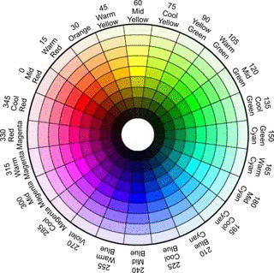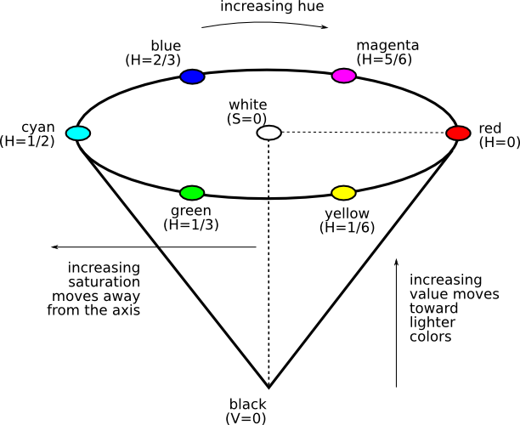

**Fig 5.2: HSV Representation of Color**

The HSV distribution of the color wheel can be seen in the following image:

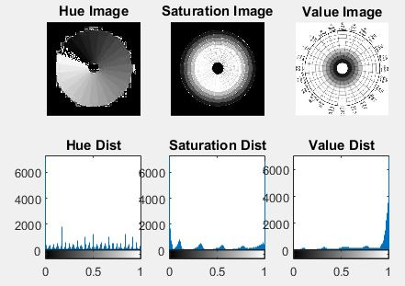

**Fig 5.3:HSV Distribution and Histogram**

**STEP 2 - APPLY A THRESHOLD MASK**

To isolate the colors, we have to apply multiple masks. A low threshold and high threshold mask for hue, saturation and value. Anything pixel within these thresholds will be set to 1 and the remaining pixels will be zero. In my algorithm, I applied a mask to get all of the red hues in the color wheel as can be seen below:



**Fig 5.4: Isolating Red Hues**

**Chapter 6: Testing**

**6.1. Definition of testing**

Software testing is an investigation conducted to provide stakeholders with information about the [quality](https://en.wikipedia.org/wiki/Software_quality) of the [software](https://en.wikipedia.org/wiki/Software) product or service under test. Software testing can also provide an objective, independent view of the software to allow the business to appreciate and understand the risks of software implementation. Test techniques include the process of executing a program or application with the intent of finding [software bugs](https://en.wikipedia.org/wiki/Software_bug) (errors or other defects), and verifying that the software product is fit for use. Software testing involves the execution of a software component or system component to evaluate one or more properties of interest

**6.2. Types of tests**

Functional testing:

* Unit testing
* Integration testing
* System testing
* Sanity testing
* Smoke testing
* Interface testing
* Regression testing
* Beta/Acceptance testing

Non functional testing:

* Performance testing
* Stress testing
* Volume testing
* Security testing
* Compatibility testing
* Install testing
* Recovery testing
* Reliability testing
* Usability testing

**6.3 Various test case scenarios considered**

a)For Detecting Mangroves and its percentage in before images and saving them.

b)For Detecting Mangroves and its percentage  in after images and saving them.

c)For Detecting Change in before and after images.

a)For 2014:

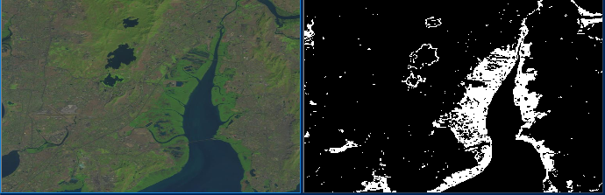

**https://lh6.googleusercontent.com/0cjPpO3O8hoq-xKHODUVg-wAIm1Sp7XQQmheBn2MFfyP3b33CpqCaxOmwlXB8NTpvpEgVevy6LnlrpetUyAgIf95Et09t0PEog7x9uZjlzyCSIOy9NuSEaKzE9tmVGpVuSk3TrY**

**Fig 6.1:Test Case 1 for before**

b)For 2019:

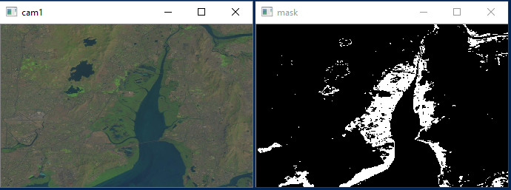

https://lh4.googleusercontent.com/8tk1DO9jzNaTVquK5iFnAigB-Bq3xNDqg3BeuYki_PAJTk_Rb13AVay8ce2nP3ZGSIjoZVd3AuuN3O8IkFiFwTZ1WItB-2taCS6ZpYtrbFouLNdHNncUVCtMPGw4lSI59X3Np4I

**Fig 6.2:Test Case 1 for after**

c) Change:

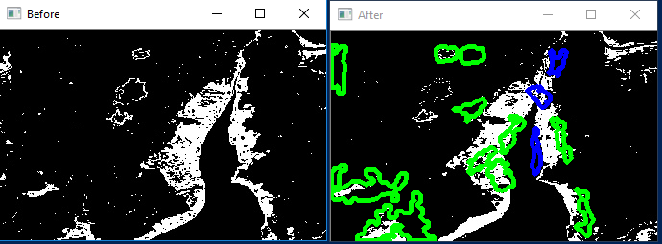

**Fig 6.3: Test Case 1 for change**

**6.5. Inference drawn from the test**

* From the above test we observed that mangrove percentage was higher in before image.
* Mangrove percentage had drastically fallen in after images.
* Drastic change in mangrove cover were marked by green outline and mild changes were marked by blue outlines.

**Chapter 7: Result Analysis**

**7.1. Module(s) under consideration**

1. Identification of mangrove destruction
2. Automatic download of data(Landsat 8)
3. Urbanization module

**7.2. Parameters considered**

1. Cloud cover

**7.3. Screenshots of User Interface (UI) for the respective module ---with its explanation**

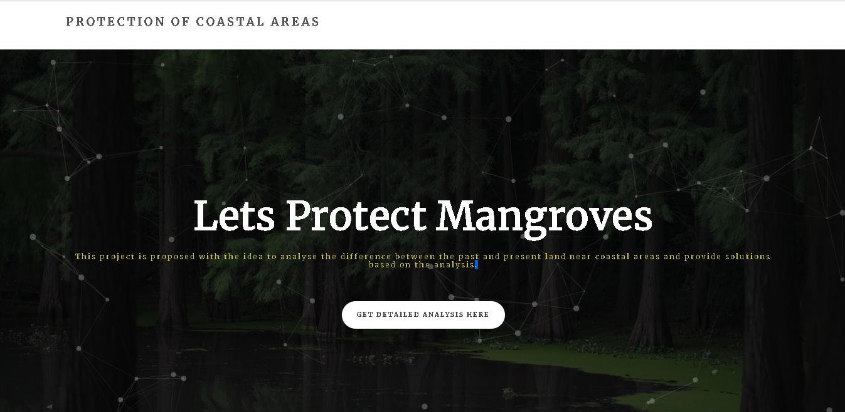

**Fig 7.1**

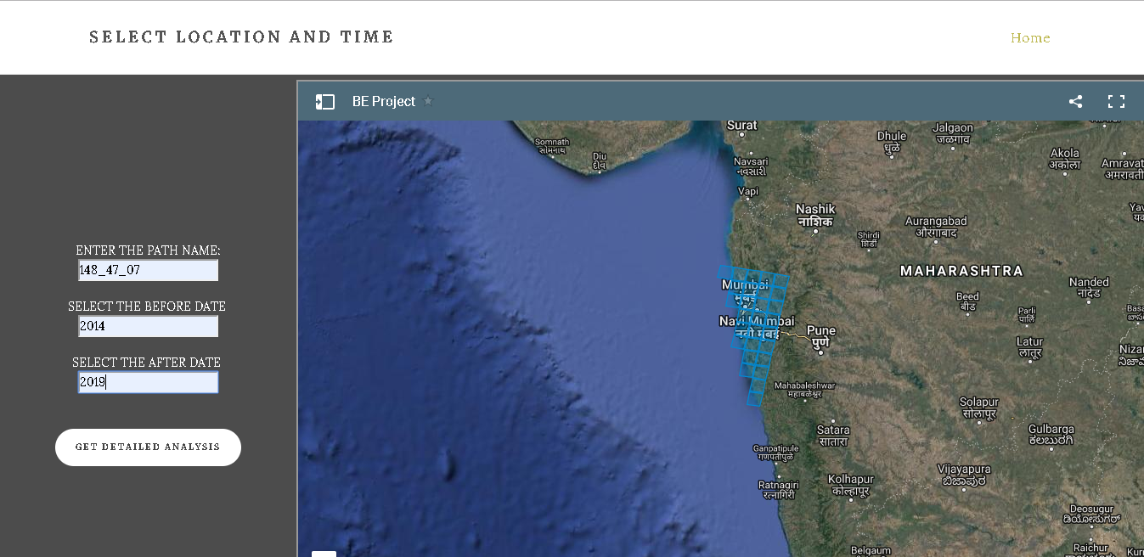

**Fig 7.2**

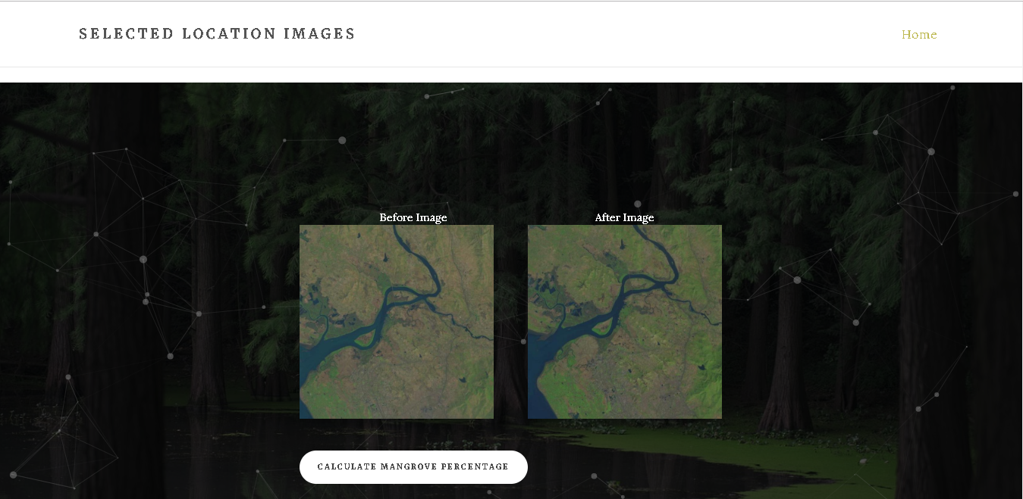

**Fig 7.3**

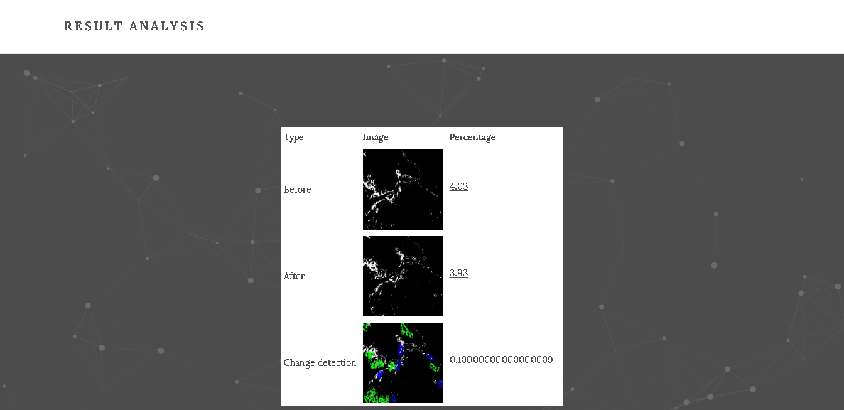

**Fig 7.4**

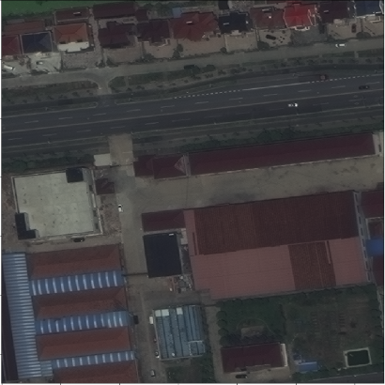

**Fig 7.5**

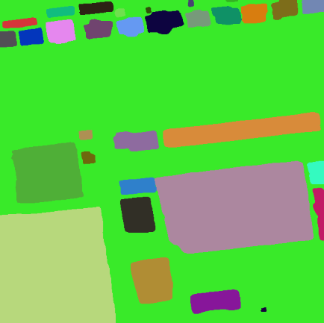

**Fig 7.6**

The Fig 7.1 shows the introductory page of  UI whereas upon clicking “Get Detailed Analysis Here” button UI would proceed to page shown in Fig 7.2 where user would be able to select the location and duration of his choice. Fig 7.3 shows the satellite image of  before and after condition of the chosen location whereas on clicking “Calculate Mangrove Percentage” button, user will get the % of mangrove in the before and after image selected as well as the %change in mangrove over selected duration of time i.e. report in the tabular form would be generated as shown in Fig 7.4. Fig 7.5 and Fig 7.6 are the demonstration of urbanization which is the root cause of mangrove destruction.

**7.4. Evaluation of the developed system**

* The result or the output of the project is in tabular form.
* The report indicates the change in mangrove(if any).
* Accuracy of the system depends on the dataset in use.
* If the urbanization module is trained properly with the datasets required, then the output will be optimal.
* The website is effective for researchers working on this domain.

**7.5. Reports generated / Tables obtained**



**Table 7.1: Report generated**

**Chapter 8:  Conclusion**

**8.1 Limitations**

* The system would not give appropriate results if the input images are not Landsat 8 images.
* Availability of Landsat 8 images is from the year 2014.

**8.2 Conclusion**

* This model will be more effective for detecting the destruction of mangrove cover.
* A report would be generated specifying the change in mangrove which would help in determining the areas where measures should be taken.
* The method of how to take information from these satellite images can be applied to different scenarios such as for determining forest cover, urbanization ,water bodies identification etc.
* These results would not only benefit our work, but also the work of thousands of other practitioners and researchers, who find it difficult to analyse the changes in the environment. The application will be open-source. We will disseminate our results close to coastal areas in Maharashtra, which will in turn help to advance land monitoring and biodiversity conservation science across the state.

**8.3 Future Scope**

Following are the Future Scope of the project:

* Expansion for area tiles
* Description of area of analysis
* Dataset for urbanization in .Tiff format

**Chapter 9: References**

**REFERENCES**

**9.1. Newspaper articles referred**

1. https://www.hindustantimes.com/mumbai-news/satellite-images-show-navy-station-reclaimed-60-mangroves-in-mumbai-ngo/story-jgL6mhtnC9XWqHLJK3YflI.html
2. https://www.dnaindia.com/mumbai/report-mangrove-research-and-training-centre-in-dharavi-soon-2230187

**9.2. Research Papers Referred (IEEE format)**

1. https://www.int-arch-photogramm-remote-sens-spatial-inf-sci.net/XLI-B8/555/2016/isprs-archives-XL I-B8-555-2016.pdf
2. https://pdfs.semanticscholar.org/bc4b/7620de3c04a9ae3e8c80040cdf199cc20c96.pdf
3. http://iopscience.iop.org/article/10.1088/1755-1315/34/1/012018/pdf
4. https://www.tandfonline.com/doi/pdf/10.5721/EuJRS20154806?needAccess=true
5. http://citeseerx.ist.psu.edu/viewdoc/download?doi=10.1.1.467.9517&rep=rep1&type=pdf
6. https://www.researchgate.net/publication/314708402_Thresholding_and_Fuzzy_Rule-Based_Classification_Approaches_in_Handling_Mangrove_Forest_Mixed_Pixel_Problems_Associated_with_in_QuickBird_Remote_Sensing_Image_Analysis
7. https://ieeexplore.ieee.org/document/6690930/
8. https://ieeexplore.ieee.org/document/8070767/

**10. Appendix**

